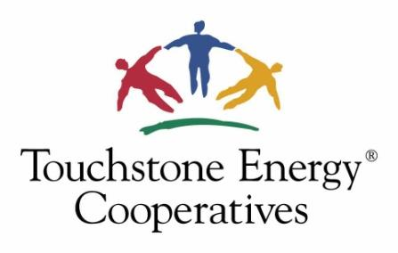

Committee Meeting 2025 – Cooperative Performance and Research Committee
Virtual

October 8, 2025

Committee Members Present:
Eric Hawkins, Trico Electric, AZ (Chair)
Beau Baggett, Cumberland EMC (TN)
Dana Bolwerk, Dairyland Power Cooperative (WI)
Emily Cowan, CHELCO, FL
Matthew Hackman, Bartholomew County REMC, IN
David Latona, DEMCO, LA
Stephanie Okuniewski, Pennsylvania Rural Electric Association, PA
Benjamin Pierson, East River Electric Power Cooperative, SD
Rita Sanders, Grand Valley, CO

Committee Members Not Present:
Chelsie Bakken, East River Electric Power Cooperative, SD
Heather Juzenas, The Energy Cooperative
Krista Williams, Cobb EMC, GA

Touchstone Energy Staff:

Angelika Hoelger

Meeting
At 10am, Chairman Eric Hawkins called the meeting to order and took roll call. Committee members approved minutes of the July 2025 committee meeting.

Updates
Angelika Hoelger provided an update on ACSI trends, available Questline content and webinars, and research projects that were recently concluded and/or will be completed over the course of 2025, including The Cooperative Advantage Report.

Research Discussion
The committee reviewed some of the topics for the 2026 Online Focus Group Reports. The committee discussed possible questions for the planned online focus group on “Broadband.”

Other Business
The committee was provided with an overview of the 2026 Cooperative Performance & Research budget. Additionally, the committee went over current committee composition and an outlook to upcoming meetings in 2026.

Eric Hawkins adjourned the meeting for the day at 10:45am.

